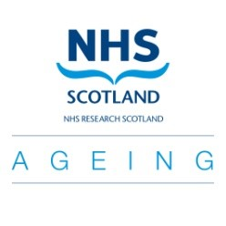 | NRS Ageing Specialty Group  NRS Ageing Specialty Group is affiliated to NIHR CRN: Ageing  Application for small grant (<£1000)
The NRS Ageing Group is pleased to be able to offer small grants (<£1000) to support work which will lead directly to an application for major grant funding for research to benefit older people in Scotland.
Name and email address
Department and Institution

Collaborators
Amount requested | Activity/item £  TOTAL
Reason for request
(Background and how this fits with remit of NRS Ageing: max 100 words)

How will this funding be used? (max 200 words)
(e.g for costs associated bringing researchers together to design a study, forming a collaborative network, support for pilot work for inclusion in a proposal)
What is your target future funding?
Please return to: Dr Susan Shenkin, NRS Ageing Specialty Group Lead
ageingscotland@ed.ac.uk

